- What is the difference between the sum of ½ and ¼ and the product of ½ and ¼?
- Bill ran a half mile in two minutes fifty-five seconds. How many seconds is that?
- The gauge of a railroad-the distance between the two tracks-is usually 4 feet 8 ½ inches. How many inches is that?
- 1 ½ ÷ 2 2/3
- 1 1/3 ÷ 4
- In six games Yvonne scores a total of 108 points. How many points per game did she average?
- Write the prime factorization of 24 and 200. Then reduce 24/200.
- $m-5\frac{3}{8}=1\frac{3}{16}$
- $3\frac{3}{5}+2=n$
- $25d=0.375$
- $\frac{3}{4}=\frac{w}{100}$
- $5\frac{1}{8}-1\frac{1}{2}$
- $3\frac{1}{3} × 1\frac{1}{2}$
- $3\frac{1}{3} ÷1\frac{1}{2}$
- $What is the area of a rectangle that is 4 inches long and 1\frac{3}{4} inches wide?$
- $(3$.2 + 1) – (0.6 x 7)
- 12.5 ÷ 0.4
- The produce 3.2 x 10 equals which of the following?
a. 32 ÷ 10 b. 320 ÷ 10 c. 0.32 ÷ 10
- Find the sum of 6416, 5734, and 4912 to the nearest thousand.
- Instead of dividing 800 by 24, Arturo formed an equivalent division problem by dividing both the dividend and the divisor by 8. Then he quickly found the quotient of the equivalent problem. What is the equivalent problem Arturo formed, and what is the quotient? Write the quotient as a mixed number.
- The perimeter of a square is 2.4 meters.
  - How long is each side of the square?
  - What is the area of the square?
- What is the tax on an $18,000 car if the tax rate is 8%?
- If the probability of an event occurring is 1 chance in a million then what is the probability of the event not occurring?
- Why is a circle not a polygon?
- Compare $\frac{1}{3} ×4$ $4\frac{1}{2} ÷3$
- Us a ruler to find the length of this line segment to the nearest eighth of an inch.
- Which angle in this figure is an obtuse angle?
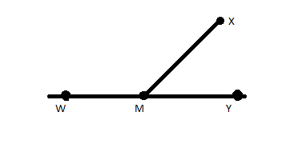
- Write 3% as a fraction. Then write the fraction as a decimal number.
- A shoe box is an example of what geometric solid?
- Sunrise occurred at 6:20am, and sunset occurred at 5:45pm. How many hours and minutes were there from sunrise to sunset?

